## *CYBER CAFE MANAGENT PROJECT*

|  |  |  |
| --- | --- | --- |
| **TABLE OF CONTENTS…** | | |
| **S,NO.** | **DESCRIPTION** | **PAGE NO.** |
| 01 | INTRODUCTION | **04** |
| 02 | OBJECTIVES OF THE PROJECT | **04** |
| 03 | PROPOSED SYSTEM | **05** |
| 04 | SYSTEM DEVELOPMENT LIFE CYCLE (SDLC) | **06** |
| 05 | PHASES OF SYSTEM DEVELOPMENT LIFE CYCLE | **07** |
| 06 | FLOW CHART | **12** |
| 07 | SOURCE CODE | **19** |
| 08 | OUTPUT | **22** |
| 09 | HARDWARE AND SOFTWARE REQUIREMENTS | **23** |
|  |  |  |

**PROJECT ON CYBER CAFE MANAGEMENT SYSTEM**

* **INTRODUCTION**

The cyber cafe management system is developed with a view of providing a better experience for customers in modern cyber cafes. It clears the doubts of the customers and helps the owner of the cyber cafe in maintaining a solid record of the customers and ensuring the paying of bills. It also helps in providing feedbacks of our cyber cafe. This is a project which helps us to understand the importance of computers in our daily life because without them there would have been no cyber cafes.

* ­­­
* **OBJECTIVES OF THE PROJECT**

The objective of this project is to let the students apply the programming knowledge into a real- world situation/problem and exposed the students how programming skills helps in developing a good software.

1. Write programs utilizing modern software tools.
2. Apply object oriented programming principles effectively when developing small to medium sized projects.
3. Write effective procedural code to solve small to medium sized problems.
4. Students will demonstrate a breadth of knowledge in computer science, as exemplified in the areas of systems, theory and software development.
5. Students will demonstrate ability to conduct a research or applied Computer Science project, requiring writing and presentation skills which exemplify scholarly style in computer science.

* **PROPOSED SYSTEM**

Today one cannot afford to rely on the fallible human beings of be really wants to stand against today’s merciless competition where not to wise saying **“to err is human”** no longer valid, it’s outdated to rationalize your mistake. So, to keep pace with time, to bring about the best result without malfunctioning and greater efficiency so to replace the unending heaps of flies with a muchsophisticated hard disk of the computer.

One has to use the data management software. Software has been an ascent in atomizationvarious organisations. Many software products working are now in markets, which have helped in making the organizations work easier and efficiently. Data management initially hadto maintain a lot of ledgers and a lot of paperwork has to be done but now software producton this organization has made their work fasterand easier. Now only this software has to beloaded on the computer and work can be done.

This prevents a lot of time and money. Thework becomes fully automated and any information regarding the organization can beobtained by clicking the button. Moreover, nowit’s an age of computers of and automatingsuch an organization gives the better look.

* **SYSTEM DEVELOPMENT LIFE CYCLE (SDLC)**

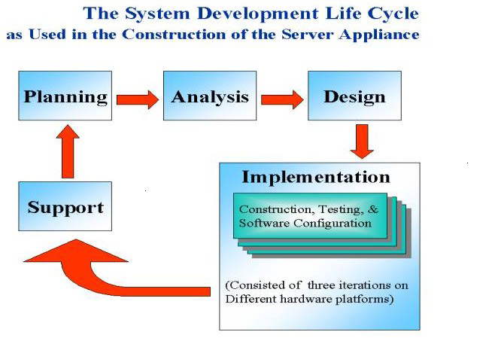

The systems development life cycle is a projectmanagement technique that divides complexprojects into smaller, more easily managedsegments or phases. Segmenting projectsallows managers to verify the successfulcompletion of project phases before allocatingresources to subsequent phases.

Software developmentprojects typically include initiation, planning,design, development, testing, implementation,and maintenance phases. However, the phasesmay be divided differently depending on theorganization involved.

For example, initialproject activities might be designated asrequest, requirements-definition, and planningphases, or initiation, concept-development,and planning phases. End users of the systemunder development should be involved inreviewing the output of each phase to ensurethe system is being built to deliver the neededfunctionality.

* **PICTORIAL REPRESENTATION OF SDLC:**

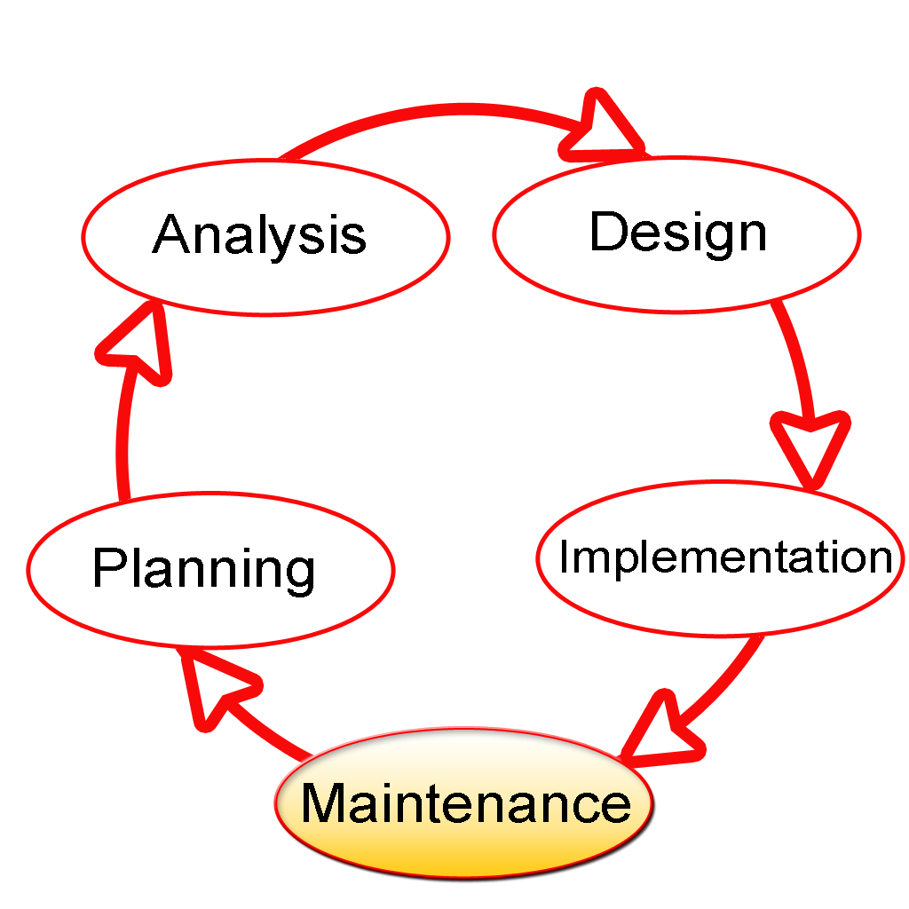

* **PLANNING PHASE**

The planning phase is the most critical step in completing development, acquisition, and maintenance projects. Careful planning, particularly in the early stages of a project, isnecessary to coordinate activities and manage project risks effectively. The depth and formality of project plans should be commensurate with the characteristics and risks of a given project. Project plans refine the information gathered during the initiation phase by further identifying the specificactivities and resources required to complete a project.

A critical part of a project manager’sjob is to coordinate discussions between user, audit, security, design, development, and network personnel to identify and document as many functional, security, and networkrequirements as possible. During this phase, a plan is developed that documents the approach to be used and includes a discussion of methods, tools, tasks, resources, project schedules, and user input. Personnel assignments, costs, project schedule, and target dates are established.

A Project Management Plan is created with components related to acquisition planning, configuration management planning, quality assurance planning, concept of operations, system security, verification and validation, and systems engineering management planning.

* **REQUIREMENTS ANALYSIS PHASE**

This phase formally defines the detailed functional user requirements using high-level requirements identified in the Initiation, System Concept, and Planning phases. It also delineates the requirements in terms of data, system performance, security, and maintainability requirements for the system. The requirements are defined in this phase to alevel of detail sufficient for systems design to proceed. They need to be measurable, testable, and relate to the business need or opportunity identified in the Initiation Phase. The requirements that will be used to determine acceptance of the system are captured in the Test and Evaluation MasterPlan.

The purposes of this phase are to:

* Further define and refine the functional and data requirements and document them in the Requirements Document,
* Complete business process reengineering of the functions to be supported (i.e., verify what information drives the business process, what information is generated, who generates it, where does the information go, and who processes it),
* Develop detailed data and process models (system inputs, outputs, and the process.
* Develop the test and evaluation requirements that will be used to determine acceptable system performance**.**
* **DESIGN PHASE**

The design phase involves converting the informational, functional, and network requirements identified during the initiation and planning phases into unified design specifications that developers use to scriptprograms during the development phase. Program designs are c onstructed in various ways. Using a top-down approach, designers first identify and link majorprogram components and interfaces, then expand design layouts as they identify and link smaller subsystems and connections. Using a bottom-up approach, designers first identify and link minor program components and interfaces, then expand design layouts as they identify and link larger systems and connections. Contemporary design techniques often use prototyping tools that build mock-up designs of items such as application screens, database layouts, and system architectures. End users, designers, developers, database managers, and network administrators should review and refine the prototyped designs in an iterative process until they agree on an acceptable design. Audit, security, and quality assurance personnel should be involved in the review and approval process. During this phase, the system is designed to satisfy the functional requirements identified in the previous phase. Since problems in the design phase could be very expensive to solve in the later stage of the software development, a variety of elements are considered in the design to mitigate risk. These include:

* Identifying potential risks and defining mitigating design features.
* Performing a security risk assessment.
* Developing a conversion plan to migrate current data to the new system.
* Determining the operating environment.
* Defining major subsystems and their inputs and outputs.
* Allocating processes to resources.
* Preparing detailed logic specifications for each software module. The result is a draft System Design Document which captures the preliminary design for the system.
* Everything requiring user input or approval is documented and reviewed by the user. Once these documents have been approved by the Agency CIO and Business Sponsor, the final System Design Document is created to serve as the Critical/Detailed Design for the system.
* This document receives a rigorous review byAgency technical and functional representatives to ensure that it satisfies the business requirements. Concurrent with the development of the system design, the Agency Project Manager begins development of the Implementation Plan, Operations and Maintenance Manual, and the Training Plan.
* **DEVELOPMENT PHASE**

The development phase involves converting design specifications into executable programs. Effective development standards include requirements that programmers and other project participants discuss design specifications before programming begins. The procedures help ensure programmers clearly understand program designs and functional requirements. Programmers use various techniques to develop computer programs. The large transaction oriented programs associated with financial institutions have traditionally been developed using procedural programming techniques. Procedural programming involves the line-by-line scripting of logical instructions that are combined to form a program.Effective completion of the previous stages is a key factor in the success of the Development phase. The Development phase consists of:

* Translating the detailed requirements and design into system components.
* Testing individual elements (units) for usability.
* Preparing for integration and testing of the IT system.
* **INTEGRATION AND TEST PHASE**
* Subsystem integration, system, security, and user acceptance testing is conducted during the integration and test phase. The user, with those responsible for quality assurance, validates that the functional requirements, as defined in the functional requirements document, are satisfied by the developed or modified system. OIT Security staff assess the system security and issue a security certification and accreditation prior to installation/implementation.

***Multiple levels of testing are performed, including***:

* Testing at the development facility by the contractor and possibly supported by end users
* Testing as a deployed system with end users working together with contract personnel
* Operational testing by the end user alone performing all functions. Requirements are traced throughout testing,a final Independent Verification & Validation evaluation is performed and all documentation is reviewedand accepted prior to acceptance of the system.
* **IMPLEMENTATION PHASE**

This phase is initiated after the system has been tested and accepted by the user. In this phase, the system is installed to support the intended business functions. System performance is compared to performance objectives established during the planning phase. Implementation includes user notification, user training, installation of hardware, installation of software onto production computers, and integration of the system into daily work processes. This phase continues until the system is operating in production in accordance with the defined userrequirements.

* **OPERATIONS AND MAINTENANCE PHASE**

The system operation is ongoing. The system is monitored for continued performance in accordance with user requirements and needed system modifications are incorporated. Operations continue as long as the system can be effectively adapted to respond to the organization’s needs. When modifications or changes are identified, the system may reenter the planning phase.

***The purpose of this phase is to:***

* Operate, maintain, and enhance the system.
* Certify that the system can process sensitive information.
* Conduct periodic assessments of the system to ensure the functional requirements continue to be satisfied.
* Determine when the system needs to be modernized, replaced, or retired.
* **FLOW CHART**

**IMPORT MYSQL.CONNECTOR AS SQL**

**CONN = SQL.CONNECT(HOST ='LOCALHOST',USER ='ROOT',PASSWORD ='',DATABASE ='CCMS')**

**IF**

**CONN.IS_CONNECTED**

**():**

**TRUE**

**PRINT("SUCCESSFULLY CONNECTED")**

**C1=CONN.CURSOR()**

**C1.EXECUTE('CREATE TABLE CUSTOMERDETAIL(Add_new_customer( VARCHAR(20),AGE INT,ADDRESS VARCHAR(60),PHONE_NO INT(10))')**

**C1.EXECUTE('CREATE TABLE BILL(CUSTOMER_NAME VARCHAR(20),TIME_ACCESSED_IN_MIN INT,TOTAL_CHARGES INT)')**

**C1.EXECUTE('CREATE TABLE TIME_CHARGES(TIME VARCHAR(30),AMOUNT_CHARGED INT)')**

**PRINT("TABLE CREATED")**

**IMPORT MYSQL.CONNECTOR AS SQL**

**CONN = SQL.CONNECT(HOST ='LOCALHOST',USER ='ROOT',PASSWORD ='',DATABASE ='CCMS')**

**IF**

**CONN.IS_CONNECTED**

**():**

**TRUE**

**PRINT("SUCCESSFULLY CONNECTED")**

**C1=CONN.CURSOR()**

**PRINT("*******AMARAVIAN CYBER CAFE WELCOMES YOU*******")**

**PRINT(“CYBER CAFE MANAGEMENT SYSTEM")**

**PRINT("1.CUSTOMER DETAILS")**

**PRINT("2.TIME CHARGES")**

**PRINT("3.BILL")**

**PRINT("4.VIEW CUSTOMER DETAILS")**

**PRINT(“5.QUIT”)**

**A=INT(INPUT("ENTER YOUR CHOICE :"))**

**FALSE**

**IF A==1:**

**TRUE**

**NAME=INPUT("ENTER YOUR NAME :")**

**AGE=INT(INPUT("ENTER YOUR AGE :"))**

**ADDRESS=INPUT("ENTER YOUR RESIDENTIAL ADDRESS :")**

**PHONE_NO=INT(INPUT("ENTER YOUR PHONE NUMBER :"))**

**TY="INSERT INTO CUSTOMERDETAIL VALUES('{}',{},'{}',{})".FORMAT(NAME,AGE,ADDRESS,PHONE_NO)**

**C1.EXECUTE(TY)**

**CONN.COMMIT()**

**PRINT(“THANK YOU VISIT AGAIN")**

**FALSE**

**IF A==2:**

**TRUE**

**TIME=INPUT("ENTER THE TIME :")**

**AMOUNT=INT(INPUT("ENTER THE AMOUNT :"))**

**SS="INSERT INTO TIME_CHARGES VALUES('{}',{})".FORMAT(TIME,AMOUNT)**

**C1.EXECUTE(SS)**

**CONN.COMMIT()**

**PRINT("THANK YOU VISIT AGAIN")**

**IF A==3:**

**FALSE**

**TRUE**

**NAME=INPUT("ENTER YOUR NAME :")**

**TIME=INT(INPUT("ENTER THE TIME YOU ACCESSED CYBER CAFE IN MINUTES :"))**

**TOTAL=TIME*30**

**QW="INSERT INTO BILL VALUES('{}',{},{})".FORMAT(NAME,TIME,TOTAL)**

**C1.EXECUTE(QW)**

**CONN.COMMIT()**

**PRINT("PLEASE PAY RS.",TOTAL)**

**PRINT("TYPE YES TO PAY YOUR BILL OR NO TO PAY IT LATER")**

**B=INPUT("TYPE YES OR NO:")**

**FALSE**

**IF B=="YES":**

**TRUE**

**PRINT("BILL PAID SUCCESSFULLY")**

**PRINT("THANK YOU VISIT AGAIN")**

**PRINT("BILL NOT PAID,PAY THE BILL TO LEAVE THE PLACE")**

**IF A==4:**

**FALSE**

**TRUE**

**phone_no=input("Enter the phone number of the customer you want to search :")**

**ea="select * from Add_new_customer where Phone_no=" + str(phone_no)**

**c1.execute(ea)**

**data=c1.fetchall()**

**for**

**row in**

**data:**

**TRUE**

**print("Name:",row[0])**

**print("Age:",row[1])**

**print("Address:",row[2])**

**print("Phone number:",row[3])**

**print("Email ID",row[4])**

**print("THANK YOU VISIT AGAIN")**

**if**

**a==5:**

**TRUE**

**print("THANK YOU VISIT AGAIN")**

**SOURCE CODE**

**SOURCE CODE FOR TABLE**

**import mysql.connector as sql**

**conn = sql.connect(host ='localhost',user ='root',password ='',database ='ccms')**

**if conn.is_connected():**

**print("successfully connected")**

**c1=conn.cursor()**

**c1.execute('create table Add_new_customer(Customer_name varchar(20),Age int,Address varchar(100),Phone_no int(10),Email_ID varchar(30))')**

**c1.execute('create table Bill(Customer_name varchar(20),Time_accessed_in_min int,Total_charges int)')**

**c1.execute('create table Time_charges(Time varchar(30),Amount_charged int)')**

**print("Table created")**

**SOURCE CODE FOR CYBER CAFE MANAGEMENT SYSTEM**

**import mysql.connector as sql**

**conn = sql.connect(host ='localhost',user ='root',password ='',database ='ccms')**

**if conn.is_connected():**

**print("successfully connected")**

**c1=conn.cursor()**

**print(“********AMARAVIAN CYBER CAFE WELCOMES YOU**********")**

**print("CYBER CAFE MANAGEMENT SYSTEM")**

**print("1.Customer details")**

**print("2.Time Charges")**

**print("3.Bill")**

**print("4.Customers detail view")**

**print("5.Quit")**

**a=int(input("Enter your choice :"))**

**if a==1:**

**name=input("Enter your name :")**

**age=int(input("Enter your age :"))**

**address=input("Enter your residential address :")**

**phone_no=int(input("Enter your phone number :"))**

**email_id=input("Enter your Email ID :")**

**ty="insert into Add_new_customer values('{}',{},'{}',{},'{}')".format(name,age,address,phone_no,email_id)**

**c1.execute(ty)**

**conn.commit()**

**print(" THANK YOU VISIT AGAIN ")**

**if a==2:**

**time=input("Enter the time :")**

**amount=int(input("Enter the amount :"))**

**ss="insert into Time_charges values('{}',{})".format(time,amount)**

**c1.execute(ss)**

**conn.commit()**

**print("THANK YOU VISIT AGAIN")**

**if a==3:**

**name=input("Enter your name :")**

**time=int(input("Enter the time you accessed cyber cafe in minutes :"))**

**total=time*30**

**qw="insert into Bill values('{}',{},{})".format(name,time,total)**

**c1.execute(qw)**

**conn.commit()**

**print("Please pay Rs.",total)**

**print("Type YES to pay your bill or NO to pay it later")**

**b=input("Type YES or NO:")**

**if b=="YES":**

**print("Bill paid successfully")**

**print("THANK YOU VISIT AGAIN")**

**else:**

**print("Bill not paid,pay the bill to leave the place")**

**if a==4:**

**phone_no=input("Enter the phone number of the customer you want to search :")**

**ea="select * from Add_new_customer where Phone_no=" + str(phone_no)**

**c1.execute(ea)**

**data=c1.fetchall()**

**for row in data:**

**print("Name:",row[0])**

**print("Age:",row[1])**

**print("Address:",row[2])**

**print("Phone number:",row[3])**

**print("Email ID",row[4])**

**print("THANK YOU VISIT AGAIN")**

**if a==5:**

**print("THANK YOU VISIT AGAIN")**

**HARDWARE AND SOFTWARE REQUIREMENTS**

I.OPERATING SYSTEM : WINDOWS 7 AND ABOVE

II. PROCESSOR : PENTIUM(ANY) OR AMD

ATHALON(3800+- 4200+ DUALCORE)

III. MOTHERBOARD : 1.845 OR 915,995 FOR PENTIUM 0R MSI

K9MM-V VIAK8M800+8237R PLUS CHIPSET FOR AMD ATHALON

IV. RAM : 512MB+

V. Hard disk : SATA 40 GB OR ABOVE

VI. CD/DVD r/w multi drive combo: (If back up required)

VII. FLOPPY DRIVE 1.44 MB : (If Backup required)

VIII. MONITOR 14.1 or 15 -17 inch

IX. Key board and mouse

X. Printer : (if print is required – [Hard copy])

* **SOFTWARE REQUIREMENTS:**

1. Windows OS
2. Python
3. Mysql
4. Mysql python connector

.